**Gym Management App User Manual**

**Adding Entities (Employee/Member)**

After pressing the add button pick which entity you would like to add:

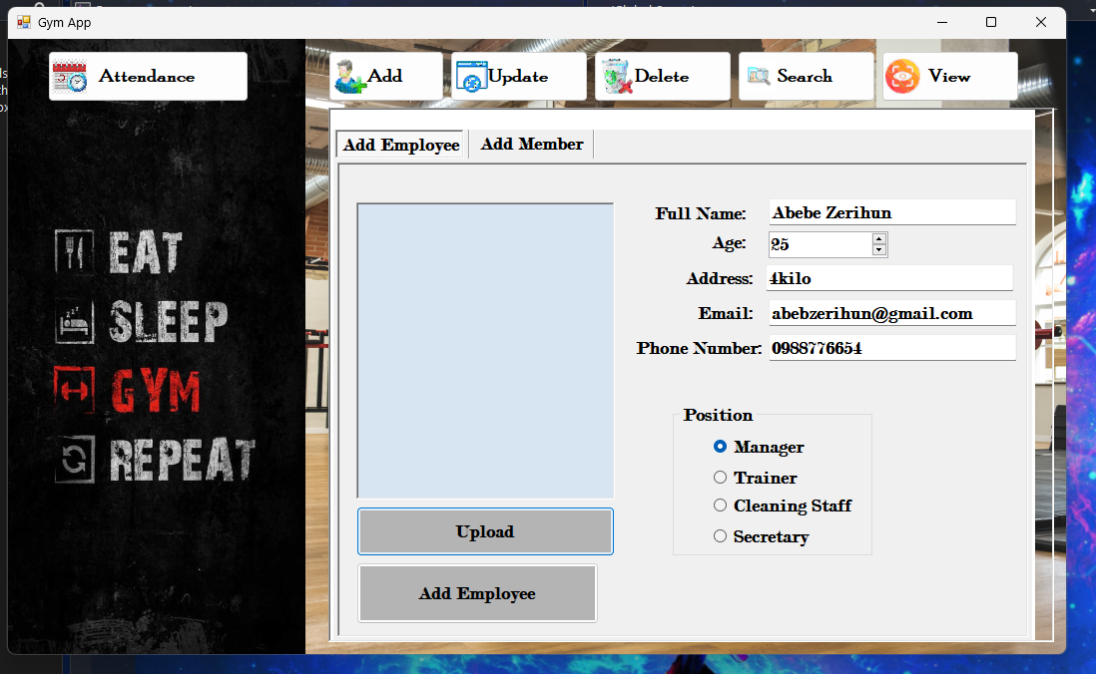

After filling out the appropriate information, press the add employee button: 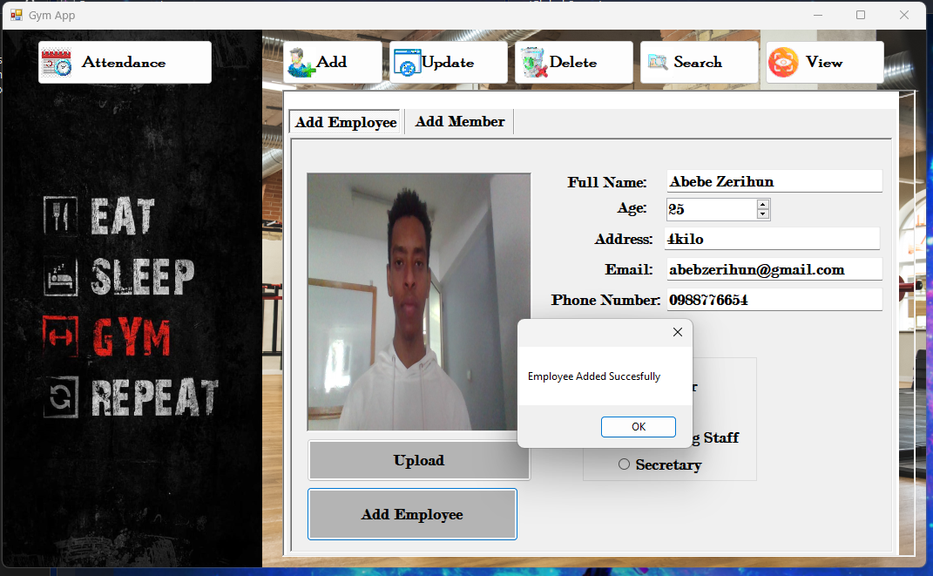

Do the same for adding members:

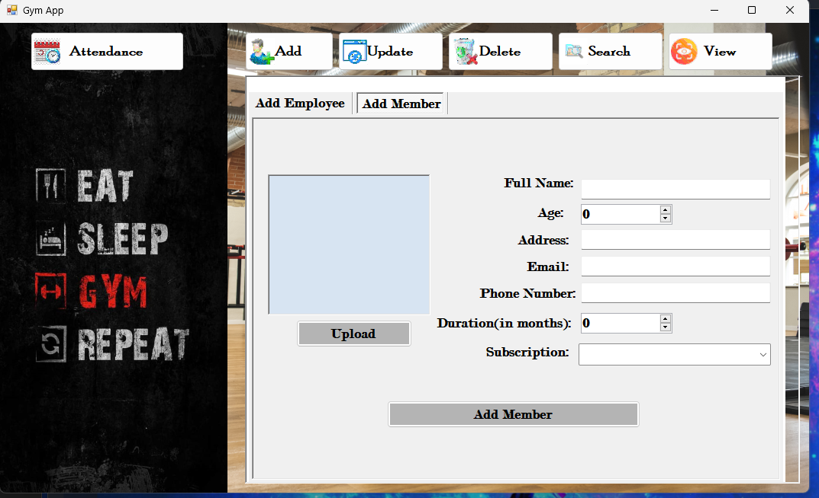

**Updating Entities**

For updating information of already added entities:

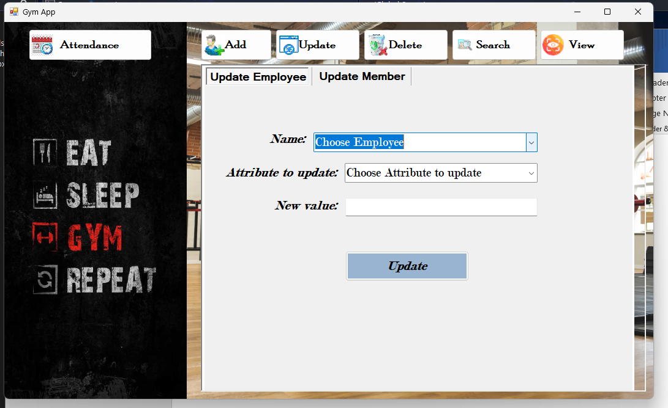

Select the name of who’s info you would like to update:

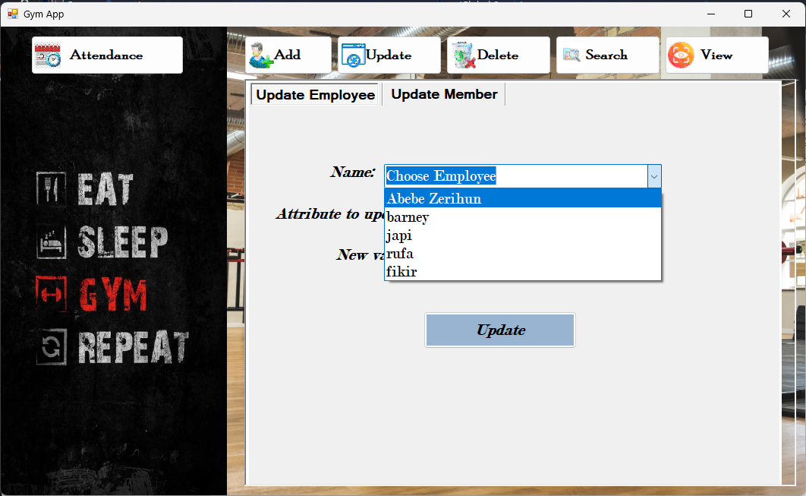

**Fill out the remaining straight forward info:**

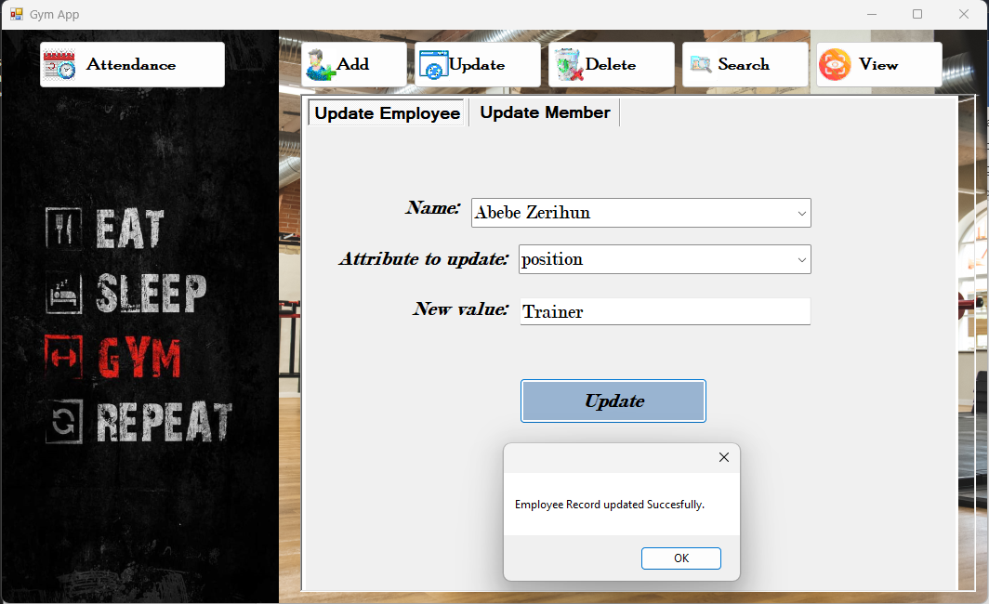

Then press the update button.

**Viewing Entities**

For viewing entities you have already added:

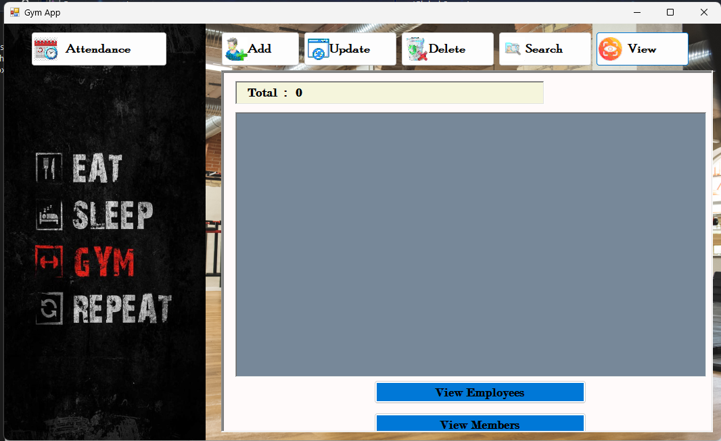

Press the button of which ever entity you would like to view: 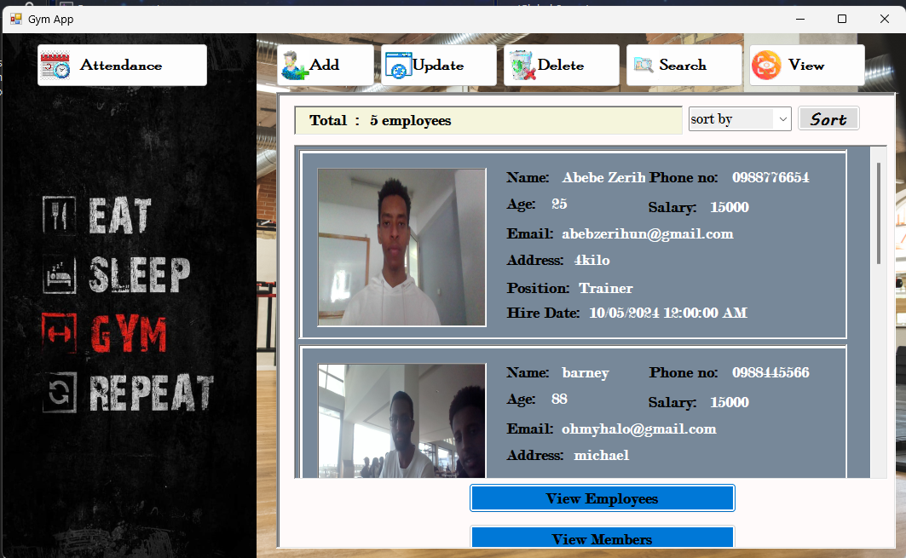

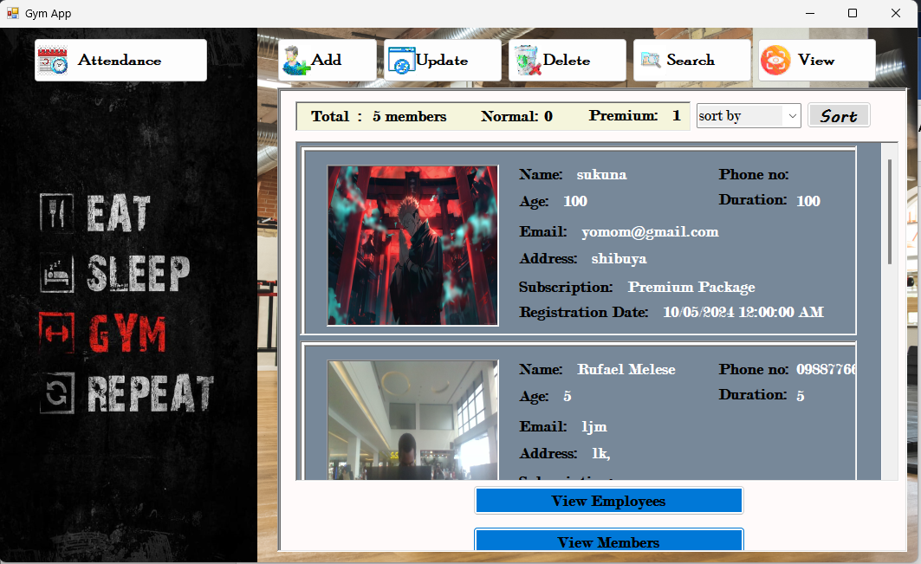

**Sorting Entities**

To sort them based on an attribute of your choice:

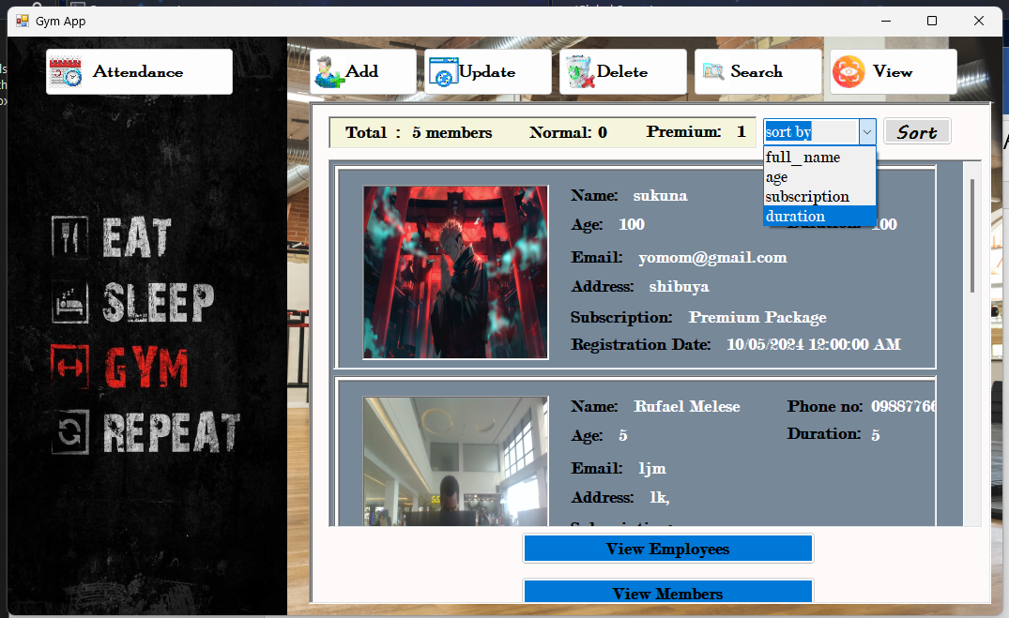

**Select the attribute then press the sort button.**

**Searching Entities**

For searching an entity its pretty straight forward:

1-Select what you would like to search

2-Type the name of the person you’re looking for(employee/member).

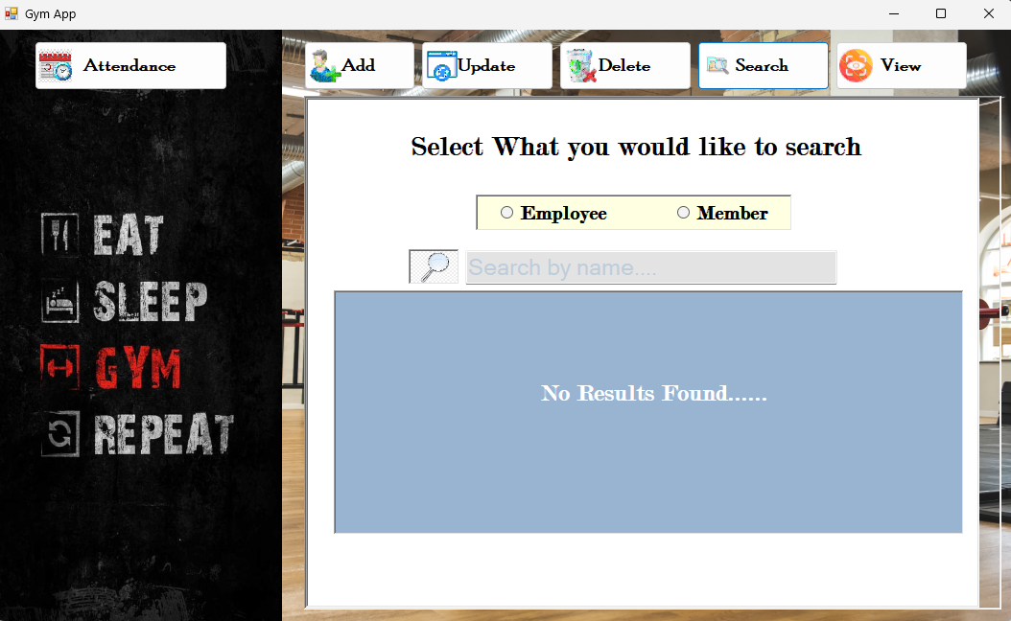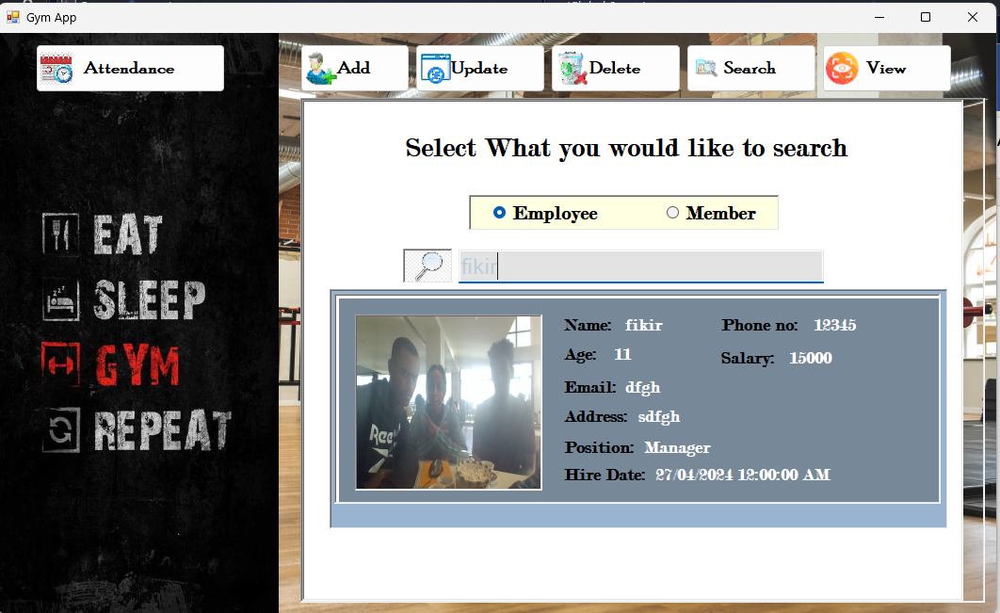

**Deleting Entities**

For deleting an entity:

1-Choose the name of who you would like to delete

2-Press the delete button.

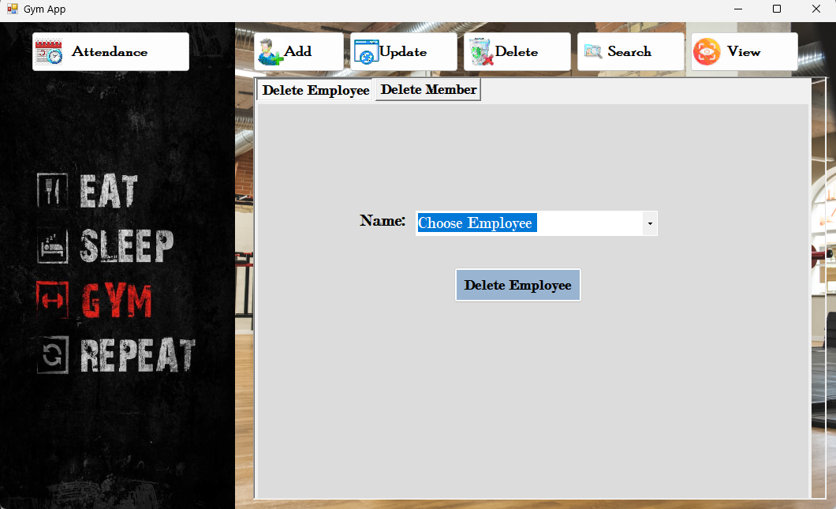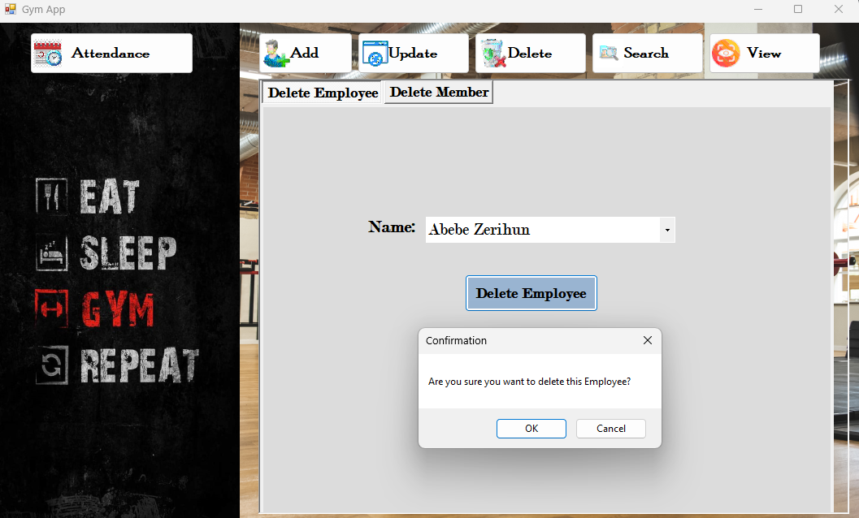

**Managing Attendance**

For taking Attendance (checking in an employee or member):

1-Choose what entity(employee/member)

2-select the name of the person you are checking in.

